Mega Door  VISION PANELS |  | 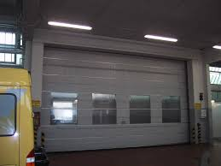
Door type | Mega Door |  | PL. indicate your requirement
Standard sizes
S-800 | 800x800, 800x1600, 1300x800, 1300x1600 (WxH)
S-1000 | 800xIPD 1300xIPD (Width x Intermediate Profile Distance)
S-1500 | Width 800 and 1300, maximum height = IPD, always check with Megadoor
Characteristics
Type | Elaston 064, 1 mm
Weight | 1230 g/m2
Hardness | 77 º Shore acc to DIN 53505
Tear resistance along/crosswise | 21 / 20 N/mm2 acc to DIN 53455
Temp. range | -30 - +50oC

